**Table of Contents**

|  |  |
| --- | --- |
| **1. General Information** | 2 |
| 1.1 Adult Educators | 2 |
| 1.2 Student Team Leadership | 2 |
| 1.3 Team Structure and Organization | 2 |
| 1.4 NAR/TRA Sections | 4 |
| **2. Facilities and Equipment** | 7 |
| 2.1 Accessible Equipment | 7 |
| 2.2 Accessible Software | 10 |
| 2.3 Communication | 11 |
| **3. Safety Plan** | 12 |
| 3.1 Risk Assessment | 12 |
| 3.2 Safety Briefings | 13 |
| 3.3 Caution Statements | 13 |
| 3.4 Rocket Motor Handling | 14 |
| 3.5 NAR procedures/personnel | 14 |
| 3.6 Law Compliance | 14 |
| 3.7 Safety Agreement | 14 |
| **4. Technical Design** | 15 |
| 4.1 Vehicle Specifications | 15 |
| 4.2 Projected Altitude | 16 |
| 4.3 Parachute System | 16 |
| 4.4 Propulsion | 20 |
| 4.5 Payload - Deployable Rover | 21 |
| 4.6 Project Requirements | 28 |
| 4.7 Major Technical challenges and solutions | 30 |
| **5. Educational Engagement** | 31 |
| 5.1 Corvallis High School | 31 |
| 5.2 West Salem High School Outreach | 31 |
| 5.3 High School Engineering Presentations | 31 |
| 5.4 Project X | 32 |
| 5.5 Educational Contacts | 32 |
| **6. Project Plan** | 33 |
| 6.1 Schedule | 33 |
| 6.2 Budget | 34 |
| 6.3 Funding | 37 |
| 6.4 Sustainability | 38 |
| **Appendices** | 39 |
| A. Copy of Safety Agreement | 40 |
| B. Octave Script to Calculate Parachute Sizes and Trajectory | 40 |
| C. Acronyms | 43 |

1. **General Information**

**1.1 Adult Educators:**

The Oregon State Rocketry Team (OSRT) has one team advisor and one team mentor whose information can be found in Table 1.1.1.

Table 1.1.1: Adult Educator Information

|  |  |  |
| --- | --- | --- |
| Name | Nancy Squires | Joe Bevier |
| Professional Title | Senior Instructor | OROC TRA TAP |
| Academic Institution | Oregon State University | Oregon State University |
| Position within OSRT | Team Advisor | Team Mentor |
| Contact | squiresn@engr.orst.edu  (541) 740-9071 | joebevier@gmail.com  (503)-475-1589 |
| TRA Number, Certification Level | TRA #15210 Level 3  NAR #97371 Level 3 | TRA #12578 Level 3  NAR #87559 Level 3 |

* 1. **Student Team Leadership:**

The OSRT has a team leader and safety officer responsible for the proper implementation of the safety plan, their information can be found in Table 1.2.1.

Table 1.2.1: Student Team Leadership Information

|  |  |  |
| --- | --- | --- |
| Name | Evan Gonnerman | Timothy Lewis |
| Title within OSRT | Team Leader | Safety Officer |
| Contact | evangonnerman@gmail.com  (503) 858-8806 | lewis@oregonstate.edu  (503) 453-6396 |
| TRA Number, Certification Level | Certification Pending | Certification Pending |

* 1. **Team Structure and Organization:**

The OSRT will consist of fifteen members from the schools of Mechanical Engineering, Electrical Engineering, and Computer Science. Furthermore, the team will involve members of the campus AIAA (American Institute of Aeronautics and Astronautics) club and students of the local high school (Corvallis High School) as an effort to enhance our educational outreach.

Due to the multi-faceted nature of this project, it has been broken up into three sub-teams, according to technical design, with the following team descriptions:

* *Structures/Propulsion* – Responsible for designing for fabrication the airframe and all internal components necessary for a successful launch and payload recovery. This team will also be in charge of implementing a proper motor while considering safety and handling before and after each launch. Key responsibilities include mass and stress analysis for altitude precision, understanding key propulsive features to ensure reliability, and monitoring of the effects of design improvements.
* *Aerodynamics-Recovery* – Responsible for the electronics behind aerodynamic stability, all parachute systems for recovery systems, and design of stability measures. Key requirements are to ensure a safe landing, monitor kinetic energy requirements, and fabricate electrical and mechanical hardware to ensure aerodynamic flight.
* *Payload* – Responsible for the design, fabrication, and testing of a rover capable of traveling five feet and deploying a set of solar panels. Key responsibilities include meeting all customer requirements, designing a payload that reliably functions, and rigorously testing prior to final launch.

Each team consists of five members with a sub-team leader responsible for ensuring all requirements are met. The team structure can be seen in Figure 1.3.1.

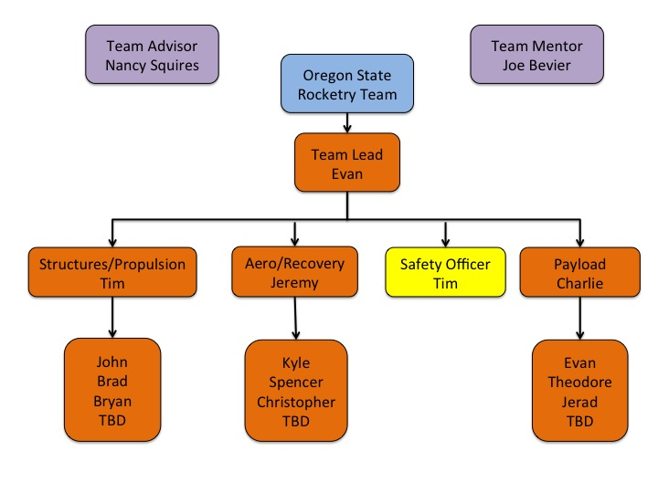Figure 1.3.1: Team Organization

* 1. **NAR/TRA Sections**

The team, if needed, may work with the following NAR/TRA groups in Table 1.4.1 for mentoring, review of designs and documentation, or launch assistance.

Table 1.4.1: NAR/TRA groups

|  |  |  |
| --- | --- | --- |
| Organization Name | Contact | NAR/TRA |
| Tripoli Portland #49 | Keith Packard | TRA |
| Eugene Rocketry (EUROC) #733 | John Lyngdal | NAR |
| Gorge Rocket Club (GRC) #790 | John Thompson | NAR |
| Oregon Rocketry Enthusiasts Organization (OREO) #555 | George Rachor | NAR |

**NAR High Power Rocket Safety Code**

These codes were acquired from the NAR website and have been in effect since August 2012. Timothy Lewis will be responsible for ensuring that the rocket and launching procedures adhere to the requirements below in order to perform safely. The physical rocket design will be in compliance with all parameters listed. All team launches will take place at an NAR/TRA certified launch site at the MSFC where an RSO will have final say over any concerns. Group members will be receiving Level 1 HPR certification before the final launch. Attached in Table 1.4.2 is a minimum distance table which outlines area clearance, before launch, based on total installed impulse. Prior to each launch, a safety meeting will be held in order to address any code issues and launch day concerns.

**Certification:** I will only fly high power rockets or possess high power rocket motors that are within the scope of my user certification and required licensing.

**Materials:** I will only use lightweight materials such as paper, wood, rubber, plastic, fiberglass, or when necessary ductile metal, for the construction of my rocket.

**Motors:** I will use only certified, commercially made rocket motors, and will not tamper with these motors or use them for any purposes except those recommended by the manufacturer. I will not allow smoking, open flames, nor heat sources within 25 feet of these motors.

**Ignition System:** I will launch my rockets with an electrical launch system, and with electrical motor igniters that are installed in the motor only after my rocket is at the launch pad or in a designated prepping area. My launch system will have a safety interlock that is in series with the launch switch that is not installed until my rocket is ready for launch, and will use a launch switch that returns to the “off” position when released. The function of onboard energetics and firing circuits will be inhibited except when my rocket is in the launching position.

**Misfires:** If my rocket does not launch when I press the button of my electrical launch system, I will remove the launcher’s safety interlock or disconnect its battery, and will wait 60 seconds after the last launch attempt before allowing anyone to approach the rocket.

**Launch Safety:** I will use a five-second countdown before launch. I will ensure that a means is available to warn participants and spectators in the event of a problem. I will ensure that no person is closer to the launch pad than allowed by the accompanying Minimum Distance Table. When arming onboard energetics and firing circuits I will ensure that no person is at the pad except safety personnel and those required for arming and disarming operations. I will check the stability of my rocket before flight and will not fly it if it cannot be determined to be stable. When conducting a simultaneous launch of more than one high power rocket I will observe the additional requirements of NFPA 1127.

**Launcher:** I will launch my rocket from a stable device that provides rigid guidance until the rocket has attained a speed that ensures a stable flight, and that is pointed to within 20 degrees of vertical. If the wind speed exceeds 5 miles per hour I will use a launcher length that permits the rocket to attain a safe velocity before separation from the launcher. I will use a blast deflector to prevent the motor’s exhaust from hitting the ground. I will ensure that dry grass is cleared around each launch pad in accordance with the accompanying Minimum Distance table, and will increase this distance by a factor of 1.5 and clear that area of all combustible material if the rocket motor being launched uses titanium sponge in the propellant.

**Size:** My rocket will not contain any combination of motors that total more than 40,960 N-sec (9208 pound-seconds) of total impulse. My rocket will not weigh more at liftoff than one-third of the certified average thrust of the high power rocket motor(s) intended to be ignited at launch.

**Flight Safety:** I will not launch my rocket at targets, into clouds, near airplanes, nor on trajectories that take it directly over the heads of spectators or beyond the boundaries of the launch site, and will not put any flammable or explosive payload in my rocket. I will not launch my rockets if wind speeds exceed 20 miles per hour. I will comply with Federal Aviation Administration airspace regulations when flying, and will ensure that my rocket will not exceed any applicable altitude limit in effect at that launch site.

**Launch Site:** I will launch my rocket outdoors, in an open area where trees, power lines, occupied buildings, and persons not involved in the launch do not present a hazard, and that is at least as large on its smallest dimension as one-half of the maximum altitude to which rockets are allowed to be flown at that site or 1500 feet, whichever is greater, or 1000 feet for rockets with a combined total impulse of less than 160 N-sec, a total liftoff weight of less than 1500 grams, and a maximum expected altitude of less than 610 meters (2000 feet).

**Launcher Location:** My launcher will be 1500 feet from any occupied building or from any public highway on which traffic flow exceeds 10 vehicles per hour, not including traffic flow related to the launch. It will also be no closer than the appropriate Minimum Personnel Distance from the accompanying table from any boundary of the launch site.

**Recovery System:** I will use a recovery system such as a parachute in my rocket so that all parts of my rocket return safely and undamaged and can be flown again, and I will use only flame-resistant or fireproof recovery system wadding in my rocket.

**Recovery Safety:**  I will not attempt to recover my rocket from power lines, tall trees, or other dangerous places, fly it under conditions where it is likely to recover in spectator areas or outside the launch site, nor attempt to catch it as it approaches the ground.

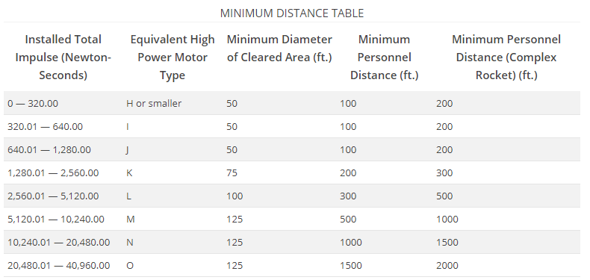  
  
Table 1.4.2: Minimum Distance Table[1]

**2. Facilities and Equipment**

**2.1 Accessible Equipment**

The OSRT has access to multiple, highly optimized work spaces for manufacturing, fabrication, and research purposes. The MIME Machining and Product Realization Lab (MIME MPRL) offers the following to students with a Fadal VMC 3016 shown in Figure 2.1.1:

* Two CNC turning stations
  + Haas SL10 with tool changer
  + EZ Path turning station
* Three CNC 3-axis mills
  + Fadal VMC 15
  + Fadal VMC 3016
  + Fadal VMC 4525
* Nine manual lathes
* Eleven manual mills
* Vertical and horizontal bandsaws
* Welding station
* Press brake
* Sand blasting station
* Stock aluminum, steel, and plastics

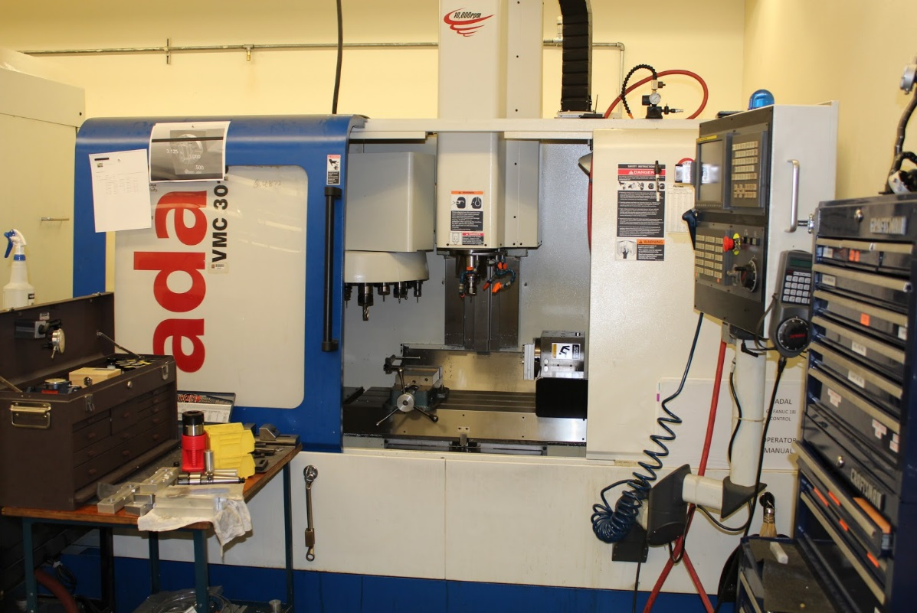Figure 2.1.1: Fadal VMC 3016 in the MIME MPRL

This shop is open any time to students upon request and has provided storage and workspace to students of the OSRT to keep all components of their project. Next to the MIME MPRL are other prototyping opportunities including two additive manufacturing machines (a Fortus 400mc and a Dimension sst 1200es) along with a fully furnished wood shop. These opportunities give rapid prototyping abilities to students of this team and are shown in Figure 2.1.2 and Figure 2.1.3.

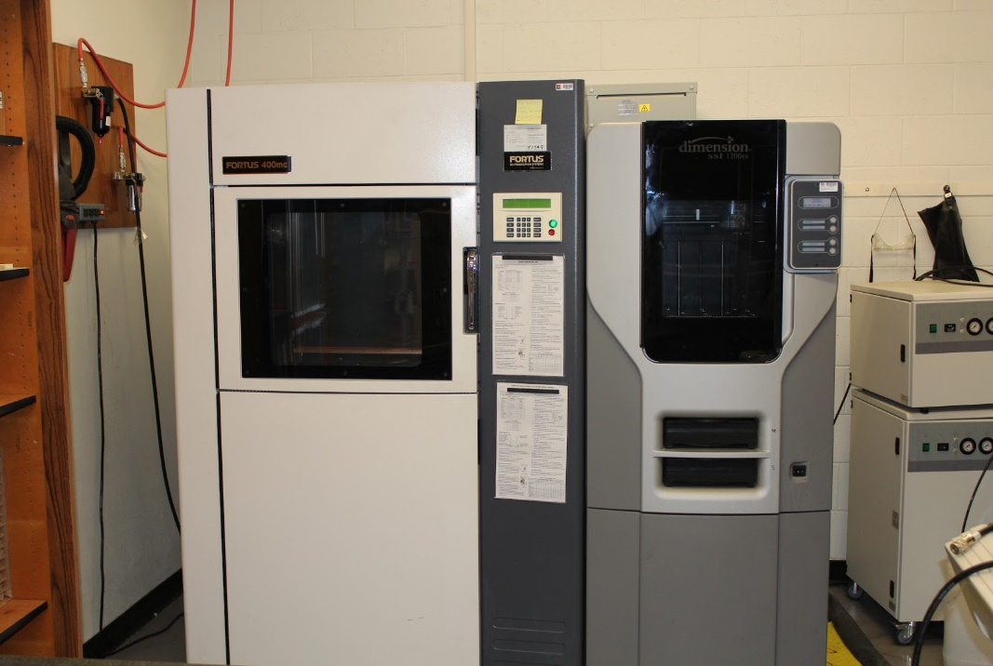Figure 2.1.2: MIME Rapid Prototyping Machines

Figure 2.1.3: MIME Woodshop

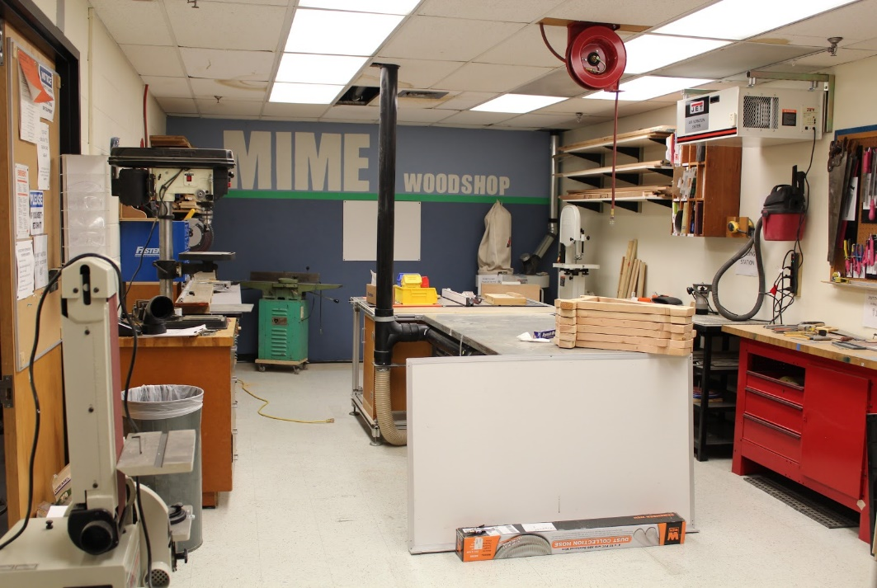

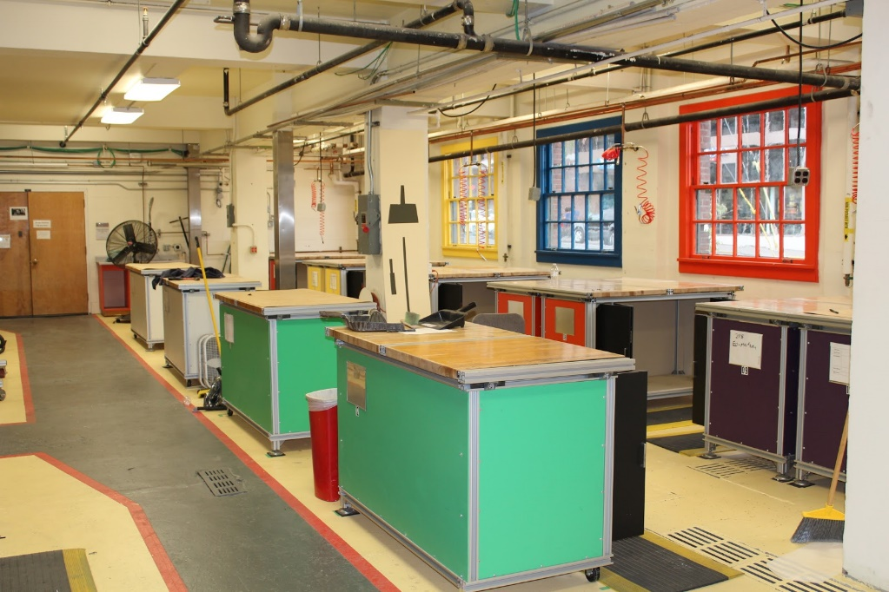Figure 2.1.4: OSRT Storage and Workspace.

The team has access to a poly cutter, composites lab complete with an oven capable of regulating necessary baking steps, and molding capabilities. Furthermore, the OSRT is partnered with the local chapter of AIAA and has access to their lab space and technical knowledge which has covered the creation and fabrication of multiple 30k to 100k rockets. The entirety of tools available include the following:

* Drill Press
* Various Hand Tools
* Composite Oven
* Poly Cutter
* Soldering Irons
* Oscilloscopes
* Pneumatic Cutting Tools
* Rapid Prototyping Capabilities
* Chop Saw
* Table Saw

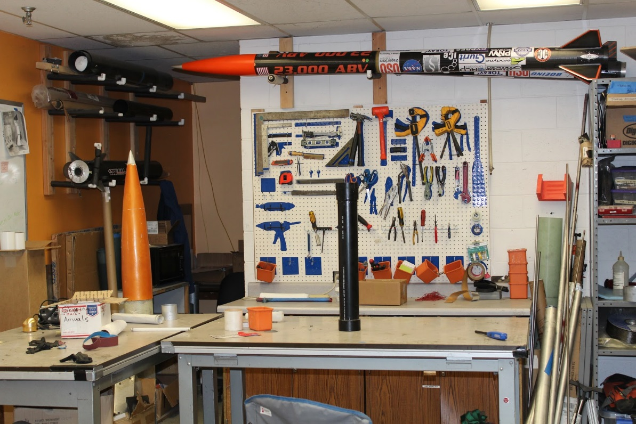Figure 2.1.5: AIAA Lab Space

**2.2 Accessible Software**

All members of the OSRT have access to computers provided by Oregon State University with many technical applications. These are located all across campus as well as on personal computers when accessed using Citrix Receiver. The applications available to students include the following:

MATLAB

SolidWorks 2016/2017

AutoCAD 2016

ANSYS

CES EduPack 2016

EES

Mathematica

Microsoft Office

Minitab

SketchUp

Adobe Acrobat

Adobe InDesign 2015

Adobe Photoshop 2015

Adobe Illustrator 2015

Open Rocket

**2.3 Communication**

The OSRT has access to conference rooms with videoconferencing capabilities provided by the OSU Communication Services department. This service is free to the ORST team through the assistance of a faculty mentor. Following the submittal of this proposal, the team lead will be reaching out to NASA contacts in order to schedule PDR, CDR and FRR video teleconferences at the convenience of all parties involved.

**3. Safety**

The Safety Officer shall be responsible for the overall safety of the project during all stages. This includes providing safety information to team members, maintenance of MSDS sheets and safety assessments, and supervise team activities for safety concerns. The safety officer will work with all sub-teams to make sure that their work includes the necessary focus on safety and will assist them in putting together procedures and safety assessments for all tasks.

**3.1 Risk Assessment**

Table 3.1.1: Risk Assessment

|  |  |  |  |
| --- | --- | --- | --- |
| Risk | Cause | Chance (1-10) | Mitigation |
| Injury From Fiberglass | Improper handling of fiberglass during rocket build | **3** | Proper PPE (Mask, Goggles, Gloves) and safety brief |
| Injury From Chemical Usage (Adhesives, Cleaners) | Breathing in or touching substances | **4** | All chemical usage will take place in well ventilated areas. Proper PPE will be used based on the MSDS of the chemical. All surfaces cleaned after chemical useage. |
| Injury From Cutting Tool (Mill, Lathe, Drill) | Improper use or preparation of the tool | **4** | All tool users must pass Machine Shop Safety Class and wearing proper PPE (Eye Protection). |
| Injury From Sanding Tool | Improper use or preparation of the tool | **3** | All tool users must pass Machine Shop Safety Class and wearing proper PPE (Eye Protection). |
| Injury From Electric Shock | Touching or working with payload and avionics components attached to live power | **2** | All Electric systems will be powered down before alteration. Only personnel directly involved with electric systems will modify said systems. |
| Burns From Heated Equipment (Soldering Irons) | Disturbing heated tools that are prepped for use or interacting with said tools when unaware they are in use. | **2** | All heated tools will be kept separate and away from the general work space. All heated tools will be turned off when not currently in use. |

|  |  |  |  |
| --- | --- | --- | --- |
| Injury from Catastrophic Failure of Motor | Defect in the motor or improper handling in preparation of motor. | 5 | Motor to be purchased from certified vendor. Motor to be handled and prepared by designated personnel. All non-essential personnel will be moved away from launch pad. |
| Injury from Rocket Test | Rocket falls before launch or | **3** | Before all launches a safety briefing shall be performed. |
| Injury from Rocket Debris due to failure of Recovery System | Parachute fails to open or separation charges fail. | **4** | All systems will be simulated and tested prior to launch. Proper drill for rocket set up will be undertaken to ensure all recovery systems are loaded and armed properly. |
| Unable to meet Project Deadlines | Design or build time overrun or miscommunication between subteams | **6** | Weekly meetings to coordinate subteams and overall team goals. Setting internal deadlines to have all deliverables finished before actual deadlines. |
| Unable to Launch on Launch Day | Destruction of airframe in testing, Failure of electronics in testing or transit | **3** | Backups for all electrical components and the airframe shall be readily accessible to fix errors. |

**3.2 Safety Briefings**

Before any construction of the rocket or fabrication of any components, all members taking part must attend a safety briefing led by the safety officer to provide all pertinent warnings for the tools and materials that will be used. This is to ensure that all team members have a complete understanding of the potential hazards and the best ways to mitigate them. It will also allow any concerns that arise to be considered and addressed as a group.

The safety officer will hold briefings before all launches to provide an overview and refresher on all safety procedures and launch site regulations. During this briefing, launch checklists will be distributed to all members to determine that all members understand the plan for the launch and their assigned roles. The distribution of launch checklists allows for all team members to be observant for deviations from the predetermined plan that could potentially be dangerous.

**3.3 Caution Statements**

In addition to safety briefings, caution statements will be placed in work instructions and additional safety information will be placed in working areas. The caution statements will include possible hazards for the portion of the build process and the appropriate PPE to mitigate those hazards. All work areas will have signs listing the appropriate PPE for the area and for any tools to be used in that area. Additionally, all work areas will have easy access to MSDS for all materials that may be use in said areas and all PPE that would be required to use such materials.

**3.4 Rocket Motor Handling**

Rocket motors will be purchased only by an NAR/TRA certified instructor. Motors and ejection charges will be stored away from ignition and heat sources. In addition NAR/TRA certified instructors will prepare all motors and ejection charges. Transportation of the rocket motors will be the responsibility of a NAR/TRA certified mentor. Motors will either be purchased on site or transported by car to the launch site.

**3.5 NAR Procedures/Personnel**

Our NAR mentor, Joe Bevier, will be responsible for ensuring that the team is completely in compliance with the NAR high power rocketry safety code. In addition, he will be in charge of all handling and transport of the rocket motors, including preparing the motors and ejection charges. He will also act as the Range Safety Officer for all full-scale test flights.

**3.6 Law Compliance**

The entire project team is fully committed to following all law and regulations pertaining to the building and launching of high powered rockets. This includes specific attention to FAA regulations pertaining to the use of airspace for rocket launches and launch sites and the NFPA codes that govern the use of high powered rocketry (NFPA 1127) to prevent fire caused by rocket use. For all rocket launches, the appropriate waiver will be requested and all launch activities will be suspended if said waiver is not issued until the waiver can be obtained.

**3.7 Safety Agreement**

All team members have read and signed the overall team safety agreement (Appendix A) and will follow all tenants set forth within.

**4. Technical Design**

Figure 4.1: Rocket Equipment Layout

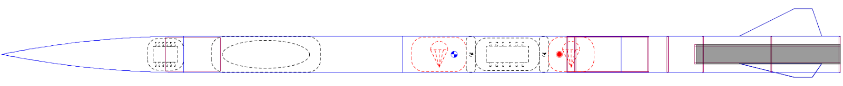

**4.1 Vehicle Specifications**

Table 4.1.1: Rocket Specifications

|  |  |  |  |
| --- | --- | --- | --- |
| **Diameter** | **Total Length** | **Loaded Weight** | **Stability** |
| 4 in | 92 in | 16.75 lb. | 3.04 cal |

The airframe will be made of G12 fiberglass. This was chosen because fiberglass is inexpensive and easy to acquire while still being a strong and effective material for rockets of this size. Using a fiberglass airframe has the additional advantage of being RF transparent. The airframe will consist of four components: the nose cone, the payload bay, the recovery bay and the motor bay. The nose cone will house the competition altimeter and the tracking device, the payload bay holds the payload and its deployment system, the recovery bay holds the drogue and main chutes with the recovery electronics and the motor bay will contain the rocket motor.

The design is based around the 4” Fiberglass Mad Dog DD rocket frame from Mad Cow Rocketry. The use of a kit airframe gives the team more time to focus on the payload and other components of the rocket. This frame will be modified by cutting the 48” bay in half to allow for our recovery system. Having the payload exit the rocket away from the parachute deployment helps to mitigate issues of parachute entanglement. In addition the fins of the rocket may be redesigned to meet the target altitude while ensuring stability.

The stability of the rocket was determined using an OpenRocket simulation as shown in Figure 4.1.1. As the design develops, the stability will be checked using this method. In addition, the final configuration of the rocket will be balanced on a fulcrum to verify the actual center of gravity of the rocket.

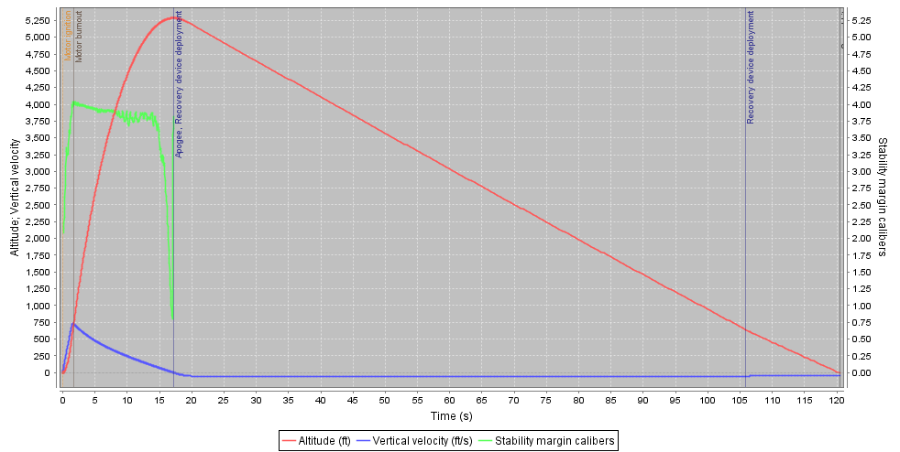Figure 4.1.1: Rocket Stability

The motor section of the rocket consists of the motor mount tube and the fins. The motor mount will be made from fiberglass and use fiberglass centering rings. The bottom of the tube will use a screwed on aluminum engine retainer to hold the motor in throughout the flight. Three fins will be used that are attached by sliding into a slot in the body and are then epoxied in place.

The recovery bay holds all of the components of the rocket needed for recovery. This includes the drogue chute, main chute, the recovery avionics and ejection systems for both chutes. This section will separate first from the motor section to deploy the drogue chute at apogee. The main chute will then deploy at a lower altitude and separate the recovery section from the payload bay.

The payload bay contains the rover and the necessary equipment to deploy the rover from the body of the rocket. This section will eject the nose cone in order to push the rover out.

**4.2 Projected Altitude**

An OpenRocket simulation was used to determine the projected altitude of the rocket. For the proposed design it was found that the maximum altitude will be at 5048 ft. with a wind speed of 5mph and 5033 ft. with a wind speed of 10 mph. In addition the angle of the launch can change the altitude by up to 40 feet.  These values will be verified for the full-scale test launch. Wind speeds will be monitored as the flight approaches.

**4.3 Parachute System**

The recovery system utilizes a two-stage parachute deployment for both the main and drogue parachutes: ejection charges separate the airframe sections in the first stage, and the parachutes deploy to slow the rocket’s descent velocity and control its stabilization in the second stage. The drogue chute launches at the apogee altitude of 5280 ft. AGL to stabilize the rocket during its initial descent and the main chute deploys at an altitude of 750 ft. AGL to slow the rocket to a safe landing velocity.

The drogue parachute was selected to have a terminal velocity of 75 $\frac{ft.}{s}$, which will allow the rocket to fall quickly in a stable trajectory in order to keep the recovery area within the required 2500 ft. radius. The velocity of the main parachute was selected to keep the kinetic energy of the entire assembly under the required 75 ft.-lbf so that the rocket could be recovered in one section. The resulting terminal velocity chosen was 15 $\frac{ft.}{s}$, which would give the assembly a maximum kinetic energy of 61.54 ft.-lbf at landing.

A toroidal canopy shape was selected for the main and drogue parachutes due to its increased packing density and drag coefficient (~2.2) compared to the other shapes. Manufacturing complexity is offset by having the manufacturing experience from OSRT in making toroidal canopies in past years.

Both parachutes are manufactured using 12 identical gores and 24 shroud lines. The outer shroud lines measure 120% of the outer diameter in length and the inner shrouds measure 27% the outer diameter in length for both parachutes, and are made from 550 lb Paracord. The parachute gores are made from Ripstop Nylon and joined together with size E Nylon thread.

To solve for the diameters, the desired velocities were input into the drag force Equation 4.3.1.

$F_{net}=F_{w}-F_{D}=mg-\frac{1}{2}ρv^{2}C_{d}A$ (Equation 4.3.1)

Where ρ is air density, v is relative velocity, Cd is the drag coefficient, and A is the parachute’s cross-sectional area. Air density at a given altitude was calculated with the barometric formula for density which accounts for the lapse rate in Equation 4.3.2.

$ρ\left(h\right)=ρ_{0}{[\frac{T_{b}}{T_{b}+L_{b}\left(h-h_{b}\right)}]}^{(1+\frac{g_{0}M}{R*L_{b}})}$ (Equation 4.3.2)

Where $ρ$ is the mass density of air, Tb is the standard temperature, Lb is the standard temperature lapse rate, h is the height ASL, hb is the height at the bottom layer, go is gravitational acceleration, M is the molar mass of air, and R* is the universal gas constant. The cross-sectional area of a toroid is given by Equation 4.3.3.

$A=\frac{π}{4}({D_{0}}^{2}-{D_{i}}^{2})$ (Equation 4.3.3)

Where Do is the outer diameter and Di is the inner diameter.  The standard ratio for Do:Di in toroidal parachutes of 5:1 is used in this design, which yields an equation for the outer diameter for a given area in Equation 4.3.4.

$D_{o}=\sqrt{\frac{25mg}{3πv^{2}C_{d}}}$ (Equation 4.3.4)

Using Equations 4.3.2 and 4.3.4 in Equation 4.3.1 and setting the result equal to the weight of the rocket will yield the parachute outer diameter for a desired descent velocity at a given altitude.

The drogue parachute measures 1.40 ft. outer diameter with a spill hole size 0.28 ft. in diameter. The bridle is sized 2.10 ft. and made of 600 lbs. 9/16” nylon webbing, and is secured to the rocket and nose cone by shock cord measuring 5 times the body length measuring 38.33 ft. to avoid collision between the main body and the booster during descent.

The main parachute measures 6.55ft. outer diameter with a spill hole 1.30 ft. in diameter. The bridle is 7.2 ft. in length and made of 600 lbs. 9/16” nylon webbing, and is secured to the rocket body and booster section by shock cord which is twice the length of the body measuring 15.33 ft.

Connections between the shrouds, bridal, and airframe are made using swivels to prevent any tangling of the parachutes or lines.

The resulting trajectory for the rocket descent was calculated assuming instantaneous parachute deployment, zero relative velocity at apogee, and starting at an altitude of 1968 ft. ASL - the average altitude of MSFC and is shown in Figure 4.3.1 while the flight sequence is shown in Figure 4.3.2.

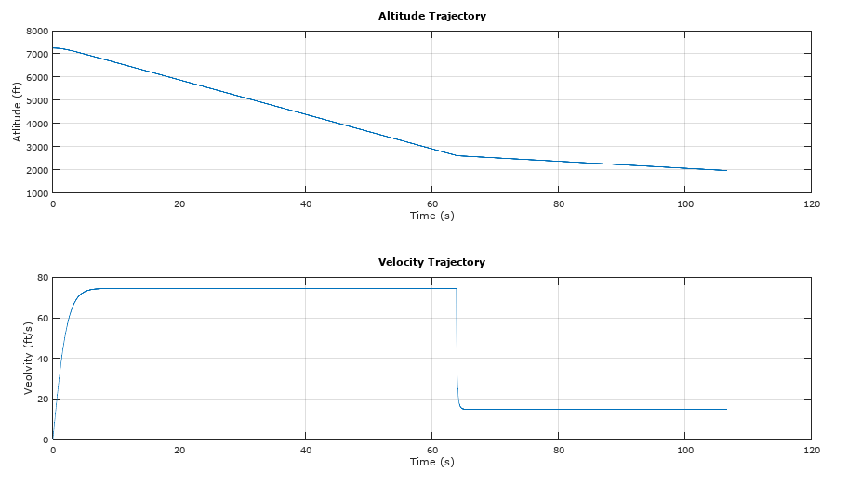Figure 4.3.1: Altitude and Trajectory

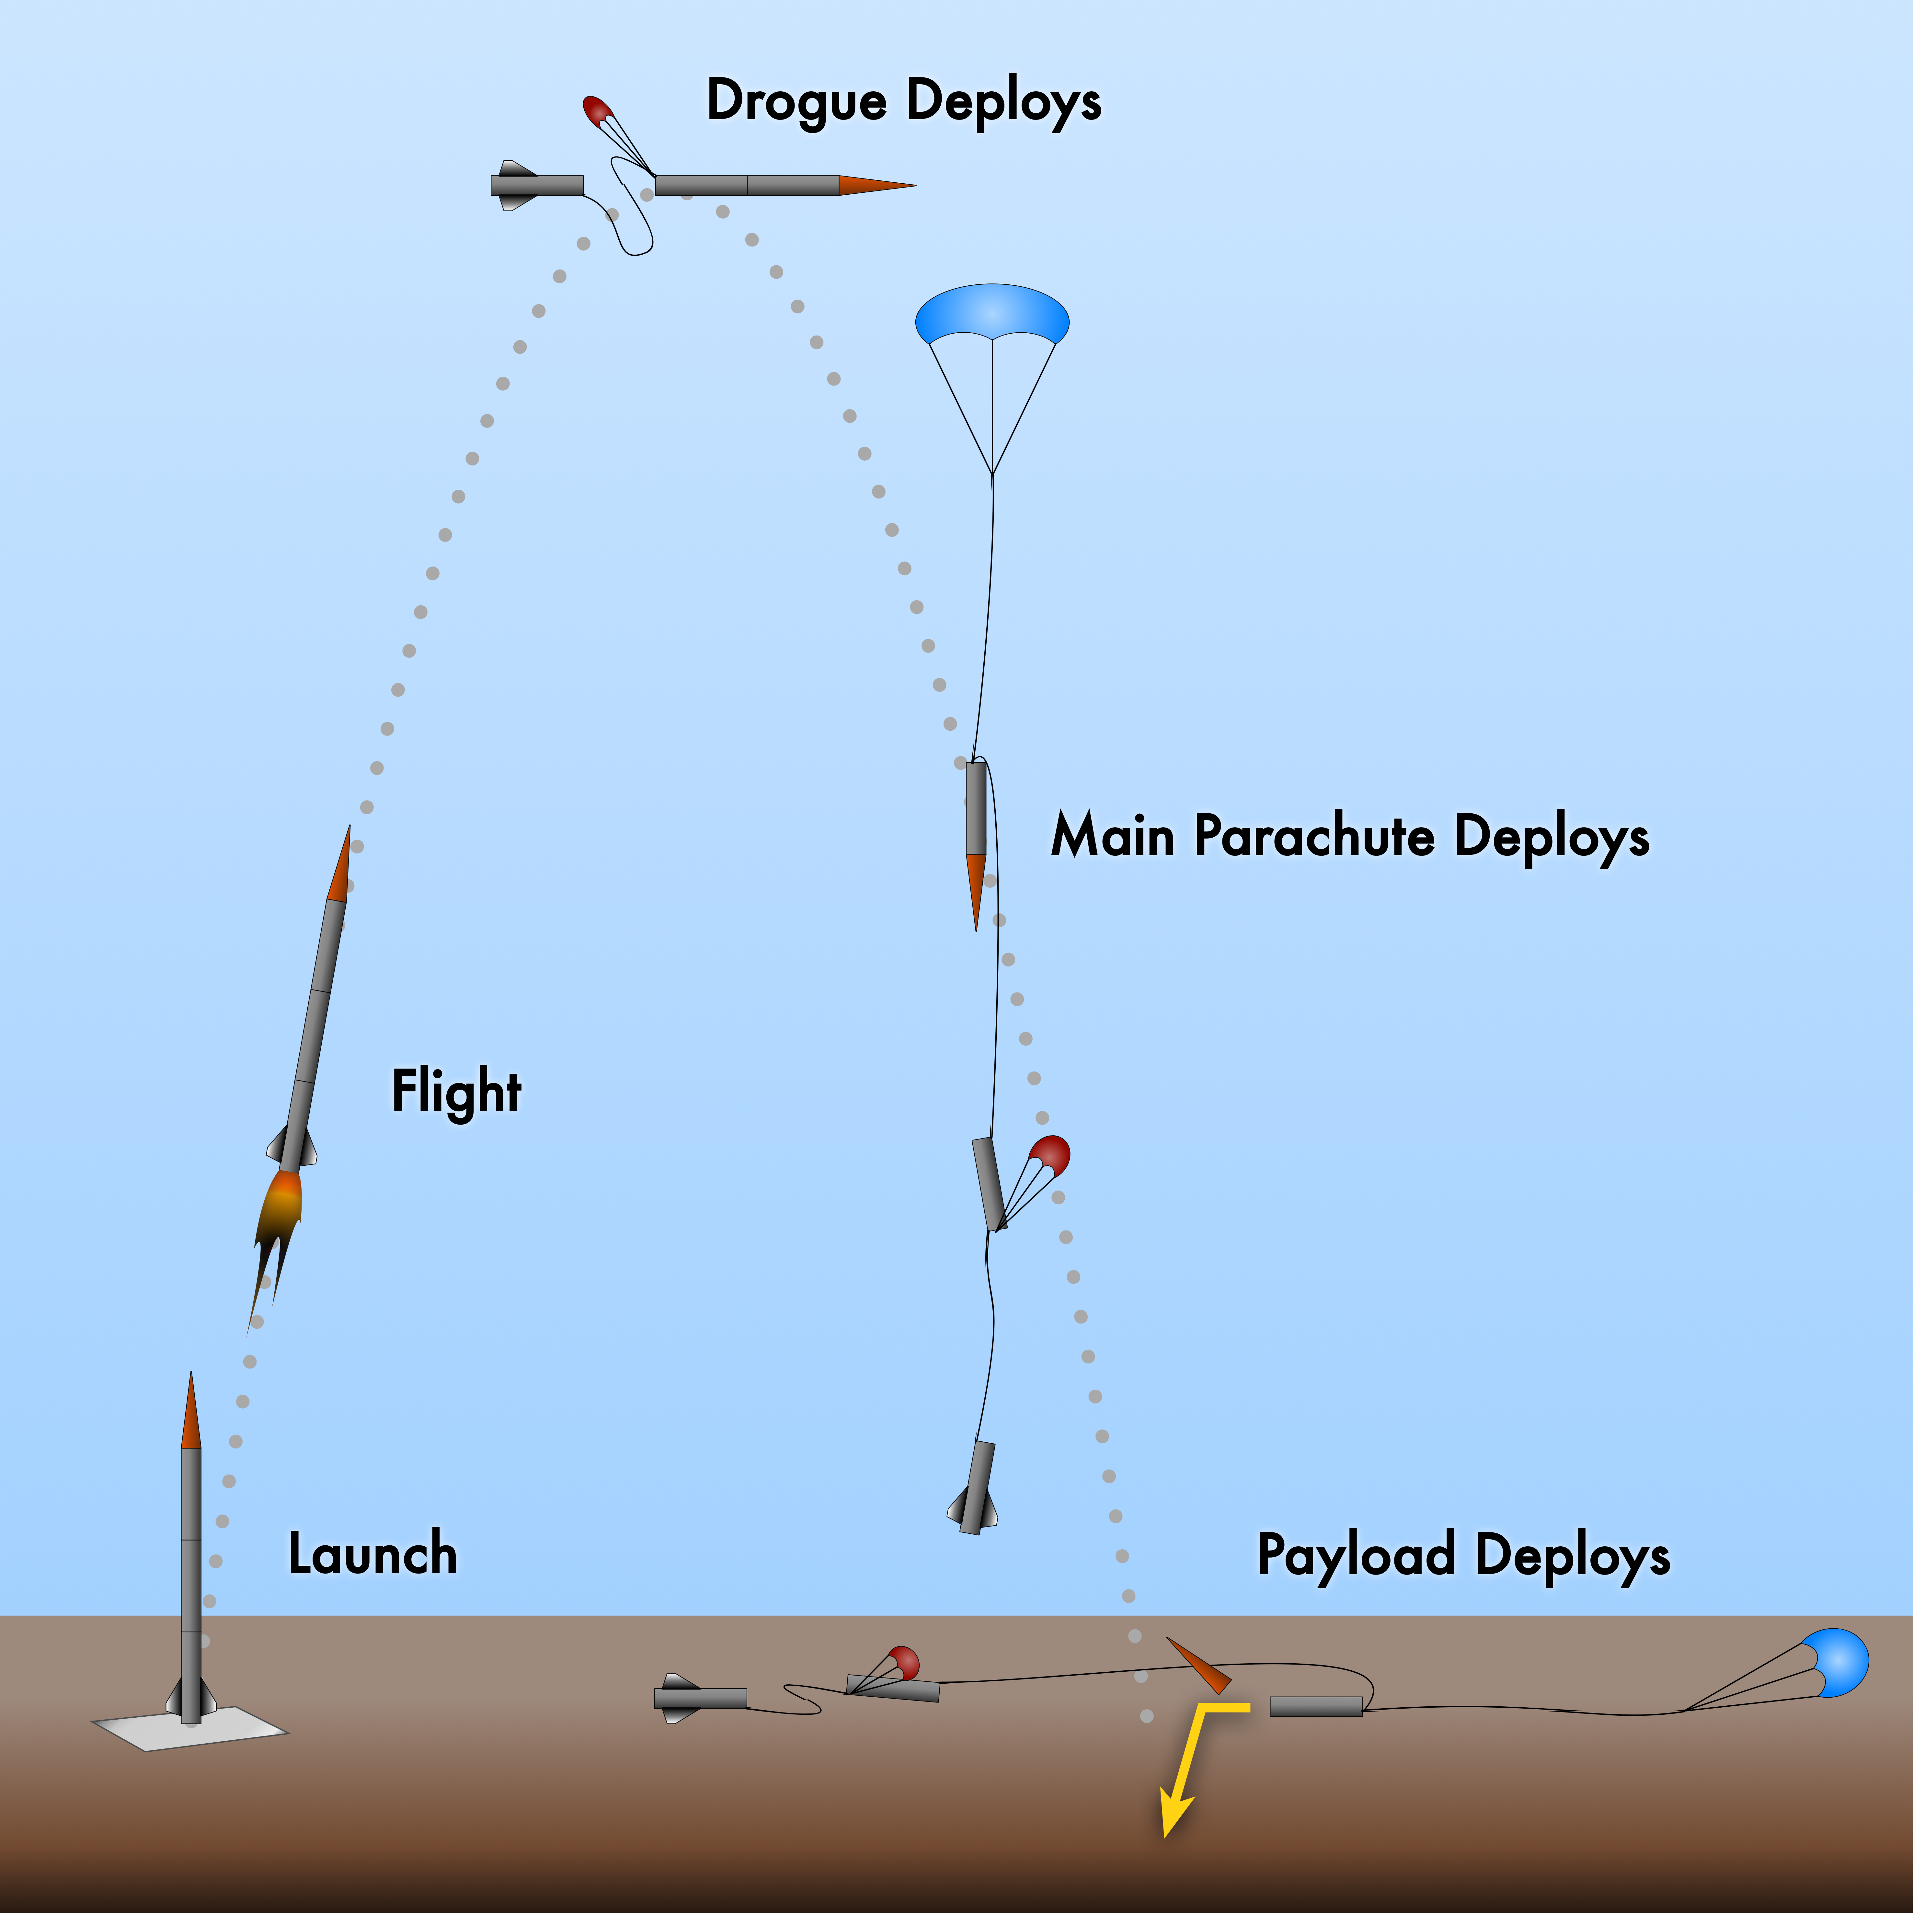Figure 4.3.2: Flight Sequence (Not To Scale)

The design requirement is that the ejection system must eject the nose cone out of the rocket by overcoming the friction between the inside of the rocket walls and the nose cone and destroying the shear pins holding the two sections in place. The system must also be robust. It must withstand multiple rocket launches and landings while remaining completely functional. The survival of the rocket completely depends on the ability of this ejection system to deploy the chute. This system will consist of an explosive mechanism. A high explosive, likely black powder, is contained within strong directional housings to force the gasses into a receiving plate attached to the other section. The resultant force destroys the shear pins, forces the sections apart, and ejects the chute. This system will be carefully designed to optimize weight distribution, force application from the explosives, and repeatability.

The shear strength of Nylon 6/6, which is what the shear pins are made of, is 10,000 psi. The amount of force required to cause yield in the shear pins can be calculated using Equation 4.3.5. Using the area of the inside of the rocket body, the pressure required to cause yield can be calculated using Equation 4.3.6. To make matters simpler, the ideal gas law can be applied to the explosive by-product gasses. Using the pressure calculated earlier, the volume chamber, the ideal gas constant, and the ignition temperature, the number of moles of gas byproducts can be obtained using Equation 4.3.7. Due to conservation of mass and assuming the rocket is sealed before yield, the number of moles of substance does not change with a chemical reaction. Thus, the number of moles before ignition in the black powder charge is the same as the rapidly expanding gasses. This gives a resultant 0.01 mols of black powder, which corresponds to about 0.02 ounces of black powder using the molar density. Since these calculations are theoretical and make a few assumptions, practical testing will be needed to ensure proper explosive strength.

$\text{τ}=\frac{F}{A}$ (Equation 4.3.5)

$\text{P}=\frac{F}{A}$ (Equation 4.3.6)

$PV=nRT$ (Equation 4.3.7)

Two independent sets of ejection charges will be used for both the drogue and main parachutes. Each set will be ignited by independent and isolated control systems with separate power supplies and EM shielding for all components.

**4.4 Propulsion**

The OSRT will be using an Aerotech K1103X-14A rocket motor with specification shown in Table 4.4.1. This motor was chosen based on our simulations and is projected to launch the rocket to the desired altitude.

Table 4.4.1: Motor Specifications

|  |  |  |  |  |  |
| --- | --- | --- | --- | --- | --- |
| Total Impulse | Burn Time | Max Thrust | Average Thrust | Loaded Weight | Propellant Weight |
| 408 lb-sec | 1.6 sec | 365 lbs | 255 lbs | 3.24 lbs | 1.74 lbs |

**4.5 Payload - Deployable Rover**

The OSRT has decided to integrate a rover that will have the capability of deploying solar panels after a set amount of travel distance. The requirements are as follows:

* Team will design a custom rover that will deploy from the internal structure of the launch vehicle.
* Upon landing, the team will remotely activate a trigger to deploy the rover from the rocket.
* After deployment, the rover will autonomously move at least 5 ft. (in any direction) from the launch vehicle.
* Once the rover has reached its final destination, it will deploy a set of foldable solar cell panels.

The rover will be a dual wheel vehicle with autonomous capabilities such as ground traversal and solar panel deployment. The single axle, two-wheel rover is a simple design which fits within the 4” diameter airframe housing. Once the rocket has reached altitude, charges will release the payload bay. After the drogue parachute deploys at apogee and the main parachute deploys at a lower altitude, the rover will land. Once deemed safe to release the rover from the housing by the safety team, a motor will activate a threaded rod plunging the rover housing from the end of the fiberglass rocket structure. The brushed motor actuating the drive shaft will activate and the rover will autonomously travel 5 ft. away from the landing site across rough terrain. Solar panels attached to the body will then deploy using a servo motor as the actuation method. The payload journey can be seen in Figure 3.5.1.

Figure 4.5.1: Schematic of Rover Journey

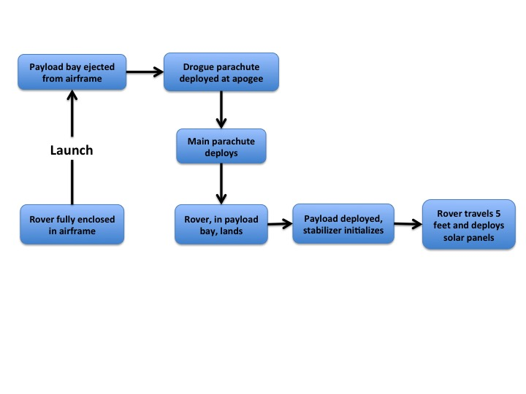

Design decisions were made from a compiled design requirements list, found in Table 4.5.1. Requirements that stood out were robustness and repeatability while weight and adaptability were not significant for the given mission.

Table 4.5.1: Design requirements for deployable rover

|  |  |  |
| --- | --- | --- |
| Design Requirements | Weight (1-5 Scale) | Justification |
| Mass | 1 | Because of size constraints, the mass can be adjusted with ease |
| Robustness | 5 | A functional rover on landing is necessary for mission success |
| Repeatability | 5 | The operation of the rover multiple times will ensure a successful mission |
| Adaptability | 1 | Because of the low distance requirement, the scope of the mission is small |
| Size Envelope | 2 | The rover does need to fit in the airframe, but can have a flexible inner diameter |
| Ease of Automation | 2 | There are multiple ways of achieving complete autonomy and is the method is not rigid |
| Integration with Airframe | 3 | Making sure the rover is deployable from the airframe is highly important |

All components on the rover were selected to increase the robustness of the vehicle while ensuring adaptation with the airframe. Particular emphasis was placed on components of the rover that actuate and necessitate reloading for repeatability. Spring loaded mechanisms and servo actuation were used while electronics were properly isolated to mitigate vibrational damage.

Because of the uneven terrain that will be on site consisting of sprouting crops and dessert like ground, the rover payload has rock crawler characteristics. The total travel distance necessary is five feet, thus necessitating a vehicle capable of traversing difficult obstacles reliably and efficiently. Components of the rover are described below and shown in Figure 4.5.2:

* Two 3.6” diameter wheels laser cut from HDPE (high density polyethylene)
* One ⅜” diameter, 7” long carbon fiber axle
* Two bearings for frame housing
* Machined aluminum mounting frame separated by polyurethane strips
* One Raspberry Pi 3 to actuate servo motors, drive motor, and autonomous capabilities
* One high torque, low rpm brushed drive motor
* One 32 pitch, 14 tooth pinion
* One 32 pitch, 28 tooth gear
* One 7.4V Lipo battery
* One 2” stabilizer for forward travel
* One set of foldable solar panels

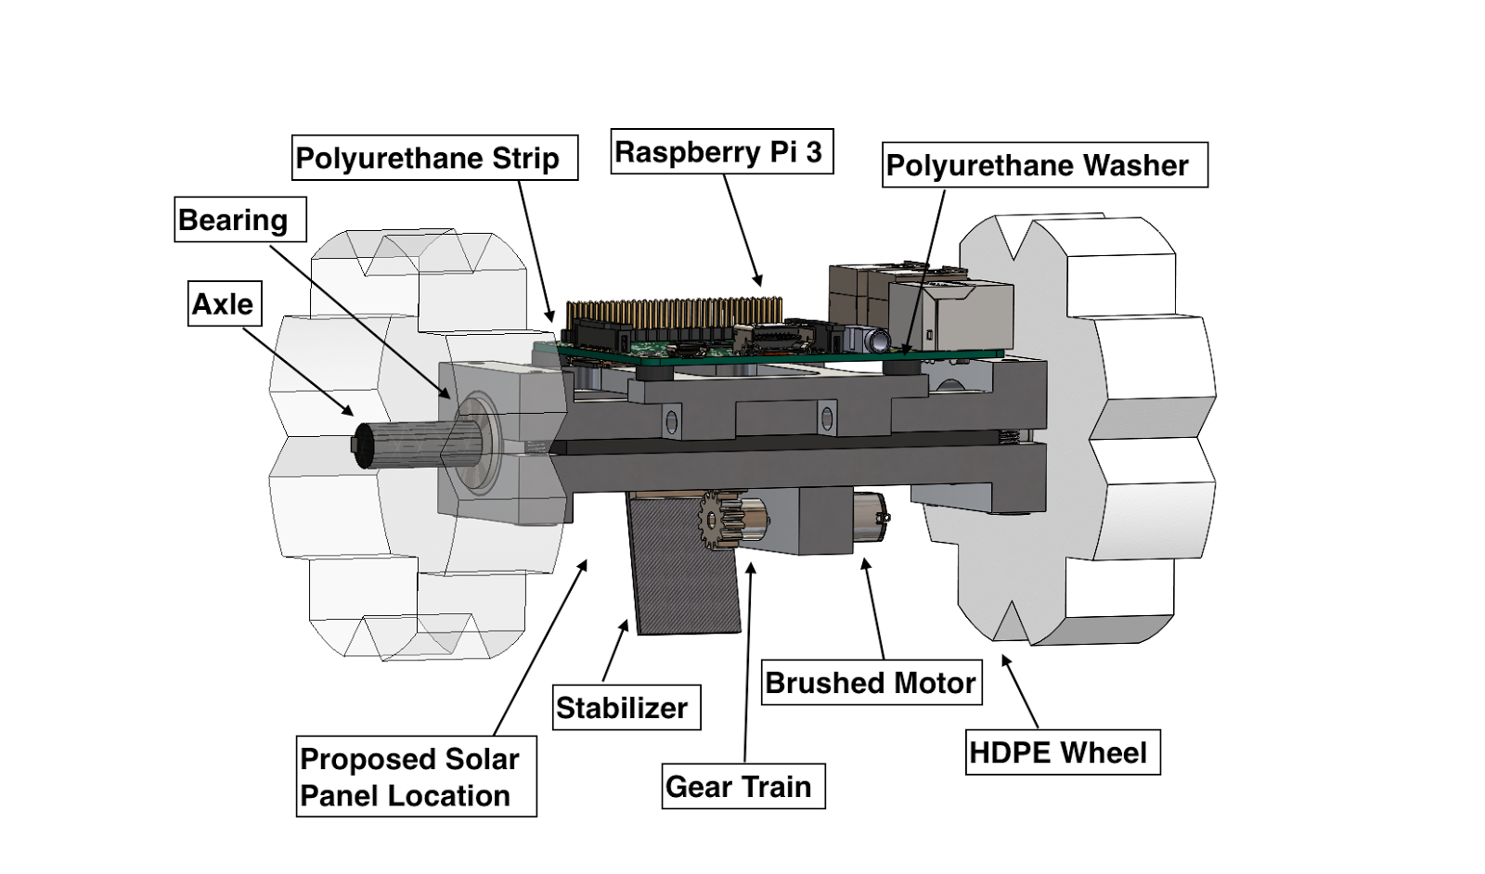Figure 3.5.2: The proposed rover with detailed components

A problem with high impact payload landings is fracture and deformation of structural components. The design behind this rover is intended to ensuring a fully functional vehicle out of the housing, capable of traversing the ground and accomplishing the successful deployment of foldable solar panels. The wheels will be custom laser cut from ½” thick HDPE, which offers high tensile strength (4,600 psi at 72o F) and excellent impact resistance (1.3 $\frac{ft.-lb.}{in}$ IZOD notched impact). Furthermore, this material can be precisely manufactured according to custom design parameters. The wheels will be fastened to a carbon fiber axle via a ⅛” square steel stock key. Carbon fiber is used as an axle instead of a drive shaft made from steel or aluminum because the increase in rigidity of carbon fiber. Weight for weight carbon fiber can be two to five times more rigid than the two metals mentioned above.

The drive shaft is run by a 6V, 220 rotations-per-minute (rpm), 2.625 lbs.-in. brushed motor. These particular motors are typically used for small rock crawlers designed for off-road traversal. The motor will turn a 32 pitch, 14 tooth pinion which, in turn, will rotate a 32 pitch, 28 tooth gear on the drive shaft. Equation 4.5.1 and Equation 4.5.2 detail the power transmission from the motor to the drive shaft.

${rpm}_{drive}={rpm}_{unit}*\frac{N_{pinion}}{N_{gear}}$ (Equation 4.5.1)

$T_{drive}=T_{input}*\frac{N_{gear}}{N_{pinion}}$ (Equation 4.5.2)

Using the calculated rpm and torque values for the drive shaft, it is possible to calculate the forward force at the wheel surface and the corresponding maximum velocity of the rover. Equation 4.5.3 and Equation 4.5.4 show the calculations used to find the forward maximum force and velocity of the vehicle. Table 4.5.2 details the values calculated for this rover.

$F_{rover}=\frac{T_{drive}}{r_{wheel}}$ (Equation 4.5.3)

$v_{rover}={rpm}_{drive}*π*d_{wheel}*\frac{1min}{60sec}$ (Equation 4.5.4)

Table 4.5.2: Drive System Technical Specifications

|  |  |
| --- | --- |
| Parameter | Value |
| $${rpm}_{drive}$$ | 110 rpm |
| $$T_{drive}$$ | 2.625 lbs.-in. |
| $$F_{rover}$$ | 1.46 lbs. |
| $$v_{rover}$$ | 20.73 $\frac{in}{sec}$ |

The computer in charge of autonomy and motor control has to have high level processing capabilities while functionally providing digital and analog I/O to actuators. A Raspberry Pi 3 was selected based off of multiple criteria. There are many well-supported sensor libraries, members on the team are familiar with the platform, and the computer has large data storage capabilities with standard file I/O. This platform interfaces through i2c and UART well for any additional sensors the team decides the rover necessitates. Possible sensors the rover may need include a camera for basic object detection. The camera will identify the brightly colored parachute to avoid entanglement. Other sensors that will be explored are a microphone pair to triangulate on sound impulses from the rocket in order to identify how far away from the rocket the rover is.

One worry regarding the computer is vibrational damage from high impact forces from the landing. A multi-stage vibrational dampening system has been designed to reduce unwanted damage to the computational system. The aluminum mounting frame will be cushioned by a two ⅛” thick, 4” long polyurethane strips. This material has a 40OO durometer typically used in super-cushioning, vibration isolation applications. Furthermore, the computer will be mounted to the aluminum frame via ⅛” thick polyurethane washers. These isolation methods will separate the Raspberry Pi 3 from any external vibrations outside of the rover movements.

The battery selected to run the rover is a Turnigy, 1600mAh, 2S, 30C Lipo pack. This battery is capable of providing the voltage requirements of the motors and the Raspberry Pi 3 (7.4V rating). Furthermore, based off a current draw of 1.3A for the computer and a maximum current draw of 0.2A for the drive motor, this motor can run the rover for 64 minutes according to Equation 4.5.5.

$t_{battery}=\frac{mAh_{battery}}{\sum_{t=1}^{n}{I_{i}}}$ (Equation 4.5.5)

The rover will have a 2” spring loaded stabilizer which will release upon being deployed on the ground. The arm will be held within the housing until it is opened, and will subsequently spring wide as the rover moves forward. The stabilizer is made from an aluminum hinge and carbon fiber extension so as to ensure no fracture upon landing. This component of the rover is one of the most important parts, as without it, the rover would spin in place without any means of forward travel. The closed and open rover pictures are shown in Figure 4.5.3 and Figure 4.5.4.

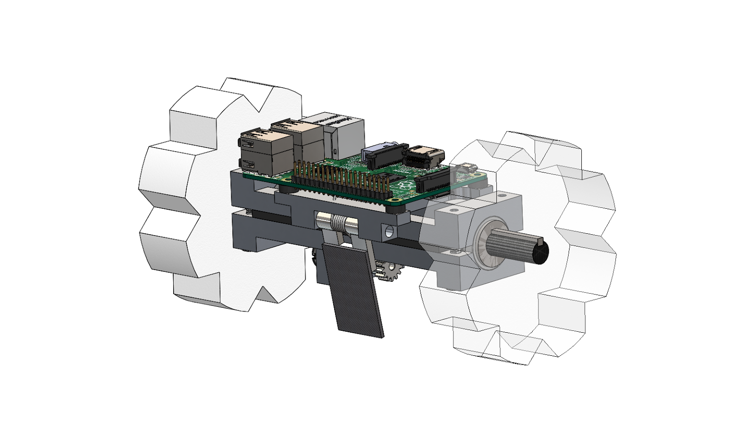

Figure 4.5.3: Rover Closed Configuration

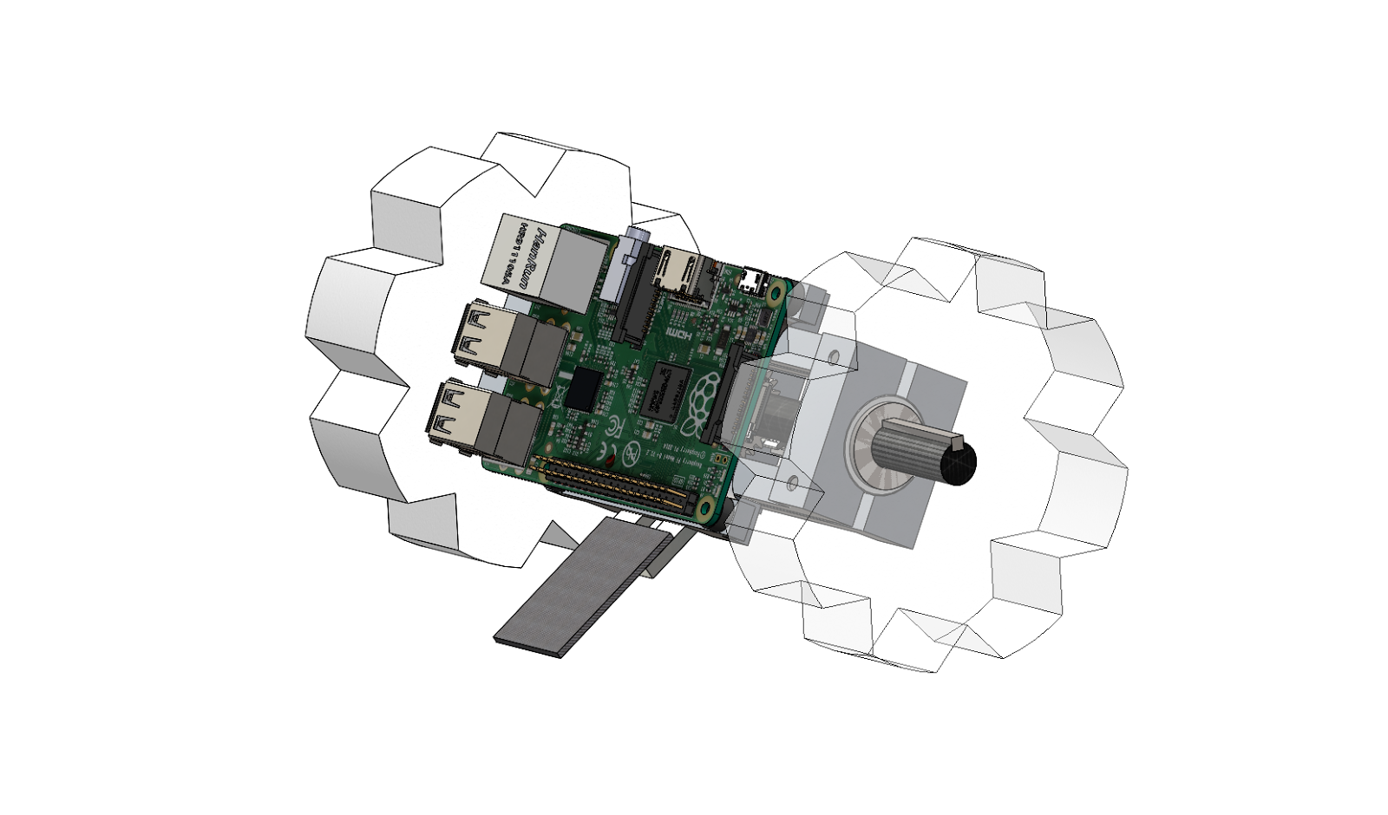Figure 4.5.4: Rover Open Configuration

The requirements for the rover place a high emphasis on robustness and compactness, but do not specify any requirements for size or power output for the solar panels. Therefore, the best folding solar panel system is one that is minimal in design and simple and consistent in operation. A simple, compact servo controlled by the Raspberry Pi 3 will be able to flip out the solar panel. The solar panel itself should be as small as is feasible, approximately 2” by 1”, to fit easily into the space available for the payload.

The servo will be mounted directly to the frame of the rover. The solar panel will be mounted to a robust platform hinged to the rover frame and connected to the servo. When the appropriate location is reached and the panel is to be deployed, the servo will activate, rotating the panel away from the rover body in a motion analogous to the opening of a pair of scissors.

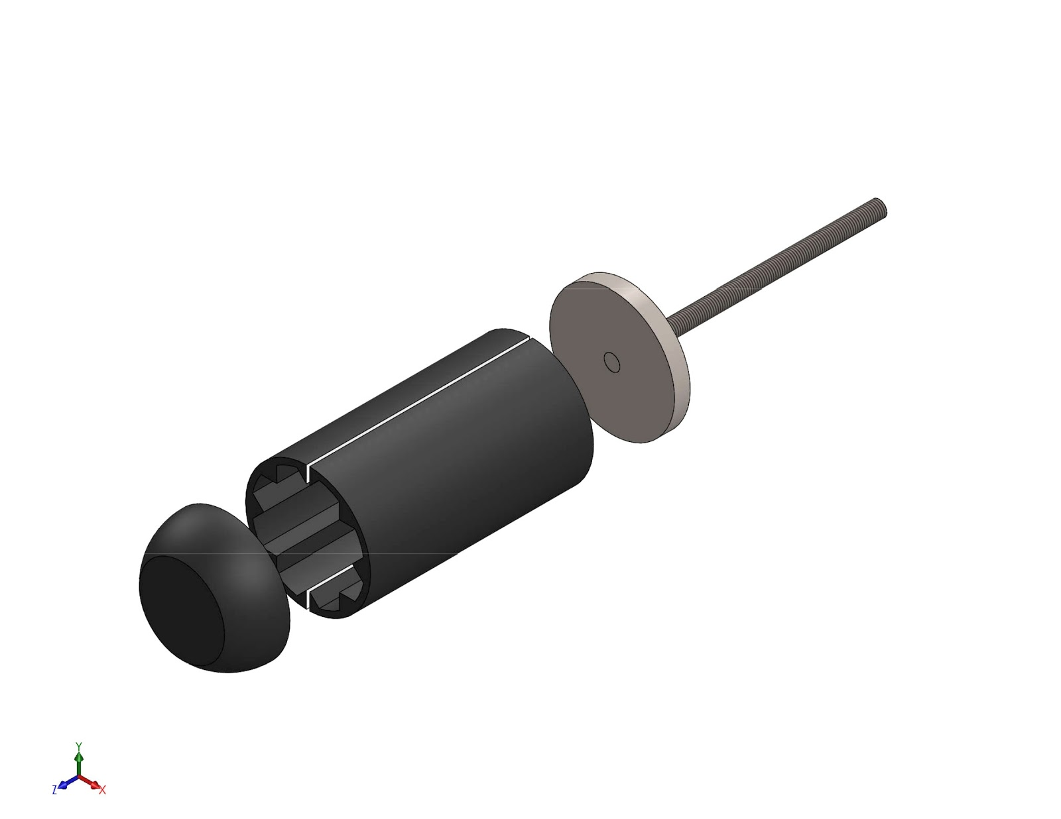Figure 4.5.5: Rover Housing

The rover will need to stay within the structure of the vehicle until landing, when it can be autonomously deployed. The OSRT rocket will detach with one section holding avionics and the other housing the payload with a mechanism responsible for putting the rover on the ground.

The rover will be encased in a high density foam mold which will protect electrical equipment throughout the entire launch sequence and provide a surface for the plunger system to impact. Once deemed acceptable by the safety crew after landfall, a brushless electric motor will drive an HDPE threaded shaft fixed to a plunger head 8” extruding the rover out the open end of the rocket frame. One section of the mold will be fixed to the plunger head, while the other section and endcap will fall freely off the rover once the stabilizer arm has been ejected.

Following this proposal the team will begin to manufacture the plunger assembly in order to properly size a motor and test its capacity to complete the task in a reliable manner.

**4.6 Project Requirements**

Table 4.6.1 Project Requirements

|  |  |
| --- | --- |
| Requirement | Solution |
| The vehicle will deliver the payload to an apogee altitude of 5,280 feet above ground level (AGL) | The motor selection is based on OpenRocket simulation to reach the required height. This will be determined as the team refines the design and get a definite weight. |
| The vehicle will carry one commercially available, barometric altimeter for recording the official altitude used in determining the altitude award winner | The rocket will contain a commercially available altimeter dedicated solely for the competition judges. |
| Each altimeter will be armed by a dedicated arming switch that is accessible from the exterior of the rocket airframe when the rocket is in the launch configuration on the launch pad. | The location of the altimeter housing allows for each altimeter arming switch to be activated from the exterior of the rocket. |
| Each altimeter will have a dedicated power supply | Avionics, recovery avionics, and payload will all have independent 9-volt power supplies. |
| Each arming switch will be capable of being locked in the ON position for launch | All arming switches will have a mechanical locking system. |
| The launch vehicle will be designed to be recoverable and reusable. | The launch vehicle will be designed to survive launch and recovery. |
| The launch vehicle will be limited to a single stage | The propulsion system will consist of only one motor. |
| The launch vehicle will be capable of being prepared for flight at the launch site within 3 hours of the time the Federal Aviation Administration flight waiver opens | The team will perform preparation drills to practice assembling and readying the rocket. |
| The launch vehicle will be capable of remaining in launch-ready configuration at the pad for a minimum of 1 hour without losing the functionality of any critical on-board components | The team will perform testing for leakage current in order to optimize energy usage of all electrical systems. |
| The launch vehicle will be capable of being launched by a standard 12-volt direct current firing system. | The rocket will have a separate launch system that is powered by an external 12-volt system. |
| The launch vehicle will require no external circuitry or special ground support equipment to initiate launch (other than what is provided by Range Services). | All electrical systems will run autonomously and wait for launch. Acceleration sensors will inform the control systems of launch. |
| The launch vehicle will use a commercially available solid motor propulsion system using ammonium perchlorate composite propellant (APCP) which is approved and certified by the National Association of Rocketry (NAR), Tripoli Rocketry Association (TRA), and/or the Canadian Association of Rocketry (CAR). | The rocket will be designed to use a standard commercial motor that meets these requirements. |
| The total impulse provided by the launch vehicle will not exceed 5,120 Newton-seconds (L-class). | The motor selection will be limited to using a K-class motor. |
| The launch vehicle will have a minimum static stability margin of 2.0 at the point of rail exit. Rail exit is defined at the point where the forward rail button loses contact with the rail. | The current design has a static stability of 2.3 at the rail exit. |
| The launch vehicle will accelerate to a minimum velocity of 52 fps at rail exit. | The rail will be built to allow the rocket to reach 52 fps at the exit of the rail. |
| Any structural protuberance on the rocket will be located aft of the burnout center of gravity | There will be no structural protuberance aft of the burnout center of gravity |
| The launch vehicle will not utilize friction fitting for motors. | The motor will be attached in a housing that uses a screw on engine retainer to hold the motor. |
| The launch vehicle will not exceed Mach 1 at any point during flight. | The motor selection will be constrained to keep the maximum velocity under Mach 0.80. |
| Vehicle ballast will not exceed 10% of the total weight of the rocket. | The rocket is designed to not utilize ballast and fin design will be used to adjust drag and stability. |
| The launch vehicle will stage the deployment of its recovery devices, where a drogue parachute is deployed at apogee and a main parachute is deployed at a lower altitude. | The rocket will utilize a dual deployment system for recovery. |
| At landing, each independent sections of the launch vehicle will have a maximum kinetic energy of 75 ft.-lbf. | The recovery system is designed with a main chute that reduces the kinetic energy of the rocket to 58.5 ft.-lbf. |
| The recovery system electrical circuits will be completely independent of any payload electrical circuits | Avionics, recovery avionics, and payload electronics will be completely isolated and shielded. |
| All recovery electronics will be powered by commercially available altimeters. | The rocket will contain three commercially available altimeters; one for avionics, one for recovery avionics, and one for the competition judges. |
| Removable shear pins will be used for both the main parachute compartment and the drogue parachute compartment. | Removable shear pins will be used to prevent early deployment of the drogue or main chutes. |
| Recovery area will be limited to a 2500 ft. radius from the launch pads. | Drogue parachute will be deployed at apogee and main parachute will be deployed at 750 ft. |
| An electronic tracking device will be installed in the launch vehicle and will transmit the position of the tethered vehicle or any independent section to a ground receiver. | The rover will utilize audio signal transmission delay and phase shift for direction and distance from the ground receiver. |
| The recovery system electronics will not be adversely affected by any other on-board electronic devices during flight (from launch until landing). | Avionics, recovery avionics, and rover will all have independent power systems. |

**4.7 Major Technical challenges and solutions**

Table 4.7.1 Major Technical Challenges and Solutions

|  |  |
| --- | --- |
| Technical Challenge | Solution |
| Release of Rover from housing upon landing | A threaded piston will push the rover out of the structure. |
| Payload separates motor engine from parachute | There will be separate parachute deployment charges used. |
| Difficult terrain | The rover will be designed with large vehicles with respect to the rest of the vehicle frame. |
| High impact landing could damage rover | The rover is contained in protective housing and constructed of impact-resistant materials. |
| Electronics in rover could be damage by high launch and landing forces | The important electronics will be vibrationally isolated from the structural body. |
| Rover deploys upside down/at odd angle | The rover will be able to rotate into place using the stabilizer spring loaded to a proper torque value. |
| Rover stabilizer does not deploy properly | The torsion spring will be properly sized to actuate the stabilizer in all orientations. |
| Rover axle deforms on landing | A carbon fiber axle will be used rather than a metal rod to disallow plastic deformation. |
| Plunger gets stuck when deploying rover | The rover will be placed in a 0.1” thick foam cylinder housing to allow for a low friction surface upon deployment. |
| Rover gets stuck in terrain | The wheels will be made to horizontally force the rover forward through frictional and surface forces. Furthermore, the stabilizer can be used to perform escape maneuvers. |
| The main recovery avionics does not deploy chutes | An independent redundant set of recovery avionics will be used to ensure chute deployment. |
| Rover gets tangled in parachute | Onboard camera able to detect brightly colored parachute and change motor direction based on input from the camera. |
| How to know when the rover has gone five feet | Rover has a pair of microphones to pick up on sound impulses coming from the rocket. Using triangulation, the rover will be able to identify distance and direction of the rocket autonomously |

**5. Educational Engagement**

The Oregon State University (OSU) College of Engineering has a long history of educational involvement with the developing youth. In the promotion of STEM (Science, Technology, Engineering, and Mathematics) fields, the college has created events throughout the year to get high school students involved. From the Undergraduate Engineering Expo every spring to communities on campus like Project X and summer camps like the STEM Academy, OSU has consistently reached out to younger generation. Just as the school has brought high school students in droves to be inspired and intrigued by the work of undergraduates only a few years apart from them, so our team is dedicated to reaching the students of tomorrow. Our participation is supplementary to the overall objective to create better awareness of the STEM community for any student participating with us, as that is our main objective.

**5.1 Corvallis High School**

Our contacts within the American Institute of Astronautics and Aeronautics (AIAA) established during last year’s ESRA educational outreach have given our team a foothold with Corvallis High School. This year the team aims to present our proof of concepts for rocketry design to the students and promote the applications of STEM fields in college. As the school is our closest proximity connection we expect to be conducting multiple events and demonstrations.

**5.2 West Salem High School Outreach**

Building off of contacts with a recently retired physics teacher and previous Oregon Teacher of the Year recipient, we intend to establish contact with his student led team promoting science and technology to Salem elementary and middle schools. By joining with these educational events we can provide a greater resource and impact to the experiments by bringing some of our own (Table 5.2.1). These events will include:

* Displaying Oregon State’s Rocketry Team posters and design models
* Interactive experiments on major concepts within all STEM fields
* Members act as Subject Matter Experts (SMEs) for all elements of rocketry, propulsion, design, and coding

**5.3 High School Engineering Presentations**

Throughout the winter, various Oregon State Rocketry Team (OSRT) members will return to their alma mater high schools to speak about college engineering, rocketry concepts, and hands-on projects you can get involved with. Students have proven in the past to be very receptive as they are eager to learn about real engineering. The events are targeted towards students taking STEM classes, and OSRT members will recruit other engineering students to provide insights from their engineering experiences.

**5.4 Project X**

Interacting with faculty, school heads, deans, and community groups, Project X stands apart within the OSU community in its tireless outreach to promote the STEM fields. This organization presents our team with one of the largest opportunities to outreach as they have interacted with, “...over 4,000 people and had really meaningful interactions with almost all of them” as stated by Aaron Fillo. Project X was founded to teach kids about what scientists and engineers actually do and as a part of their good work the ORST team can make a difference in our community and promote why we got into engineering in the first place.

**5.5 Educational Contacts**

In addition to each of the educational outreaches that have been established, there are multiple contacts that are still being explored for potential outreaches. We have established contact with Springfield K8 and are developing contacts with Sunset High School. Each of our contacts will allow for an extended educational outreach that we will utilize to demonstrate fundamental concepts of engineering and its applications throughout college.

Table 5.2.1: Team Classroom Workshops

|  |
| --- |
| Electronics Fundamentals |
| Introduction to Circuitry |
| MATLAB/Programing Techniques & Applications |
| SolidWorks / CAD modeling Demonstrations |
| Fundamentals of Rocketry |
| Nozzle Importance and Application |
| Thermodynamic Combustion |
| Design Process |

**6. Project Plan**

**6.1 Schedule**

Table 6.1.1: Gantt Chart

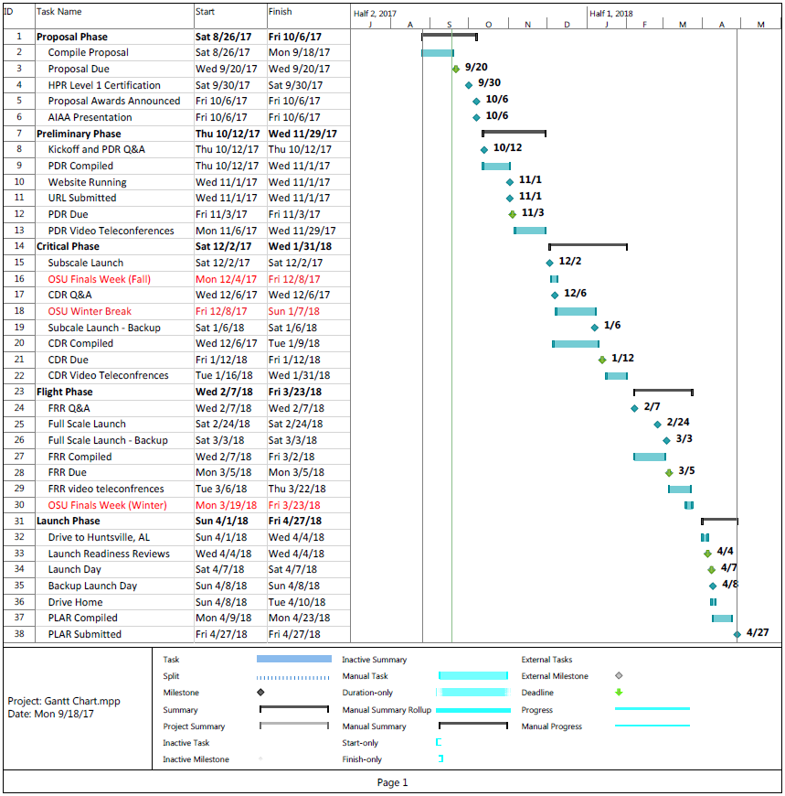

**6.3 Funding**

The main body of funding to support the Oregon State USLI has been preliminarily secured through the Oregon NASA Space Grant Consortium. The Consortium is a program, which originated in 1988 and has developed to establish a national network of universities with interest and capabilities in aeronautics, space, and related fields. As the proposal has been pre-approved for funding, Charlie Sanford will be working alongside project mentors to develop a plan and budget proposal in accordance with the specific 2017 guidelines.

To supplement the NASA grant, Charlie will be reaching out to corporate partners in order to receive monetary donations, educational mentorship, and rocket components. The Oregon State University AIAA team has existing corporate sponsors, the bulk of which are listed below. Donations from these organizations will be split among project teams according to need.

Figure 6.3.1: Funding Sources

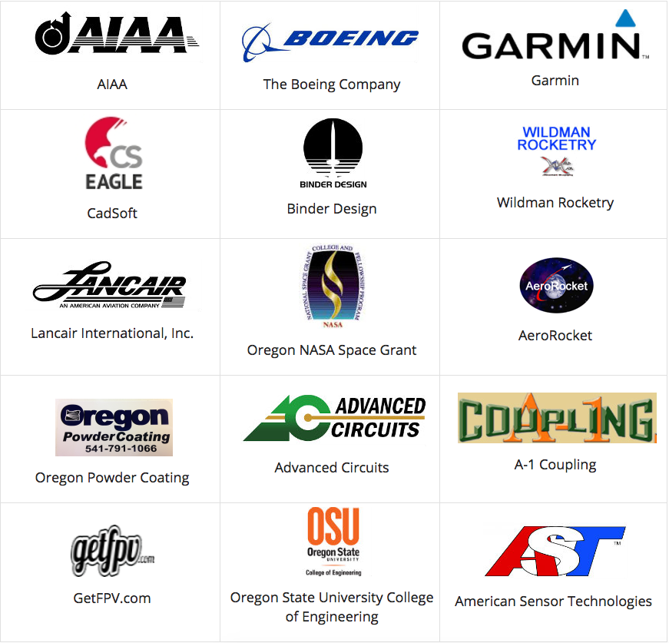

**6.4 Sustainability**

Since this is the first year the OSRT will participate in the USLI, the team this year has a responsibility to build a solid foundation for future iterations of the team to grow from. We are not starting from scratch, however. OSU has had an AIAA branch since 2013 and has fielded several different aerospace competition teams in that time. Thus there already exist resources for us to draw on in terms of expertise from students and faculty as well as the established partnerships and sponsorships with industry mentioned in the funding section above.

The most important aspect to determine the long-term sustainability of a project team like this is, of course, the ability to recruit and retain student members. The primary source of members this year has been from students seeking to complete their capstone project in engineering, and this should only grow in the future. This is the first year OSU has offered an aerospace engineering minor to mechanical engineering students, and as more students begin to take advantage of this program and the minor becomes more established, more students will be introduced to our team, and will provide a larger base for recruitment.

Our educational outreach to schools will also serve to introduce new generations of engineering students to rocketry and to our team. As they enter OSU, our continued presence and outreach at university events will bring in more and more people interested in rocketry.

**Appendices**

**Appendix A:** **Copy of Safety Agreement**

I, _____________, have read, understood and will abide by the laws and regulations governing high powered rockets and their use as set down by the National Association of Rocketry, the Federal Aviation Administration and the National Fire Prevention Association. I understand that these regulations are for my safety and the safety of others and that any violation will be properly punished.

I understand that before any launch the rocket must be inspected by the Range Safety Officer (RSO) to ensure that the rocket meets all range safety requirements. The RSOs decision will be final and not disputed and his no-go will prohibit the rocket from launching.

I understand and will follow all safety rules set down for using the Oregon State University facilities and for all building and launch activities. I will only use tools and machines that I have been properly trained and certified on with the appropriate PPE.

I understand that violation of any of the above is grounds for removal from the team and further action if the offence warrants

___________________________  ________

Sign         Date

**Appendix B: Octave Script to Calculate Parachute Sizes and Trajectory**

%% Calculations to support parachute diameter selection and plot trajectories

%% Kyle

%% 9/14/2017

%% OSR USLI 18

clear

clf

clc

%% Known

AccGrav = 32.174; % [ft/s^2] gravitational acceleration

DragCoeff = 2.2; % Drag coeff. of toroidal parachute

Weight = 17.69; % [lb] weight of rocket assembly

Mass = Weight / AccGrav; % [slugs]

HeightLaunch = 1968; % [ft] launch altitude ASL

HeightApogee = HeightLaunch + 5280; % [ft] apogee altitude ASL

HeightMain = HeightLaunch +650; % [ft] main deployment altitude ASL

VelApogee = 0; % [ft/s] apogee velocity

% Confirm Main and Drouge Velocities

VelMain = 15; % [ft/s] main chute terminal velocity

VelDrouge = 75; % [ft/s] drouge chute terminal velocity

% Calculate Required Diameters based on terminal velocities:

% Deployent height used for caluclation

diamCalc = @(h,v) sqrt((25*Weight) ./ (3*pi*airdensity(h)*DragCoeff.*v.^2));

DiamMain = diamCalc(HeightMain,VelMain);

DiamDrouge = diamCalc(HeightApogee,VelDrouge);

% Plot Termial velocities vs Parachute Diameter at apogee and main altitudes

VelVector = [15:150];

DMainVector = diamCalc(HeightMain,VelVector);

DDrougeVector = diamCalc(HeightApogee,VelVector);

figure(1)

plot(VelVector,DMainVector, 'b')

hold 'on'

plot(VelVector,DDrougeVector,'r')

grid 'on'

legend('4000 ft ASL','7248 ft ASL')

hold 'on'

plot(VelMain,DiamMain,'b',"marker",'+')

hold 'on'

plot(VelDrouge,DiamDrouge,'r',"marker",'+')

axis([0 150 0 7])

title('Terminal Velocity of Toroidal Parachute')

xlabel('Terminal Velocity (ft/s)')

ylabel('Parachute Diameter')

%% Trajectory Calculations

% Calculations for Drouge Chute Acceleration Distance

AreaDrouge = 6*pi*DiamDrouge^2/25;

accDrouge = @ (v,h) AccGrav - airdensity(h)*DragCoeff*AreaDrouge*v^2/(2*Mass);

j = 1;

VelAccel(j) = VelApogee;

HeightAccel(j) = HeightApogee;

AccAccel(j) = accDrouge(VelAccel(j), HeightAccel(j));

TimeAccel(j) = 0;

dt=.01;

while(VelAccel(j) < 74.4) %74.4 ft/s is drouge terminal velocity

j = j+1;

HeightAccel(j) = HeightAccel(j-1) - VelAccel(j-1)*dt;

VelAccel(j) = VelAccel(j-1) + AccAccel(j-1)*dt;

AccAccel(j) = accDrouge(VelAccel(j-1), HeightAccel(j-1));

TimeAccel(j) = TimeAccel(j-1) + dt;

endwhile

%% Calculate Terminal Velocity porition of drouge

i=1;

TimeTermDrouge(i) = TimeAccel(end)+dt;

VelTermDrouge(i) = VelAccel(end);

HeightTermDrouge(i) = HeightAccel(end) - VelAccel(end)*dt;

while(HeightTermDrouge(i) > HeightMain)

i=i+1;

VelTermDrouge(i) = VelTermDrouge(i-1);

HeightTermDrouge(i) = HeightTermDrouge(i-1) - VelTermDrouge(i-1)*dt;

TimeTermDrouge(i) = TimeTermDrouge(i-1) + dt;

endwhile

%Calculation for Main Chute Deceleration Distance

AreaMain = 6*pi*DiamMain^2/25;

accMain = @ (v,h) AccGrav - airdensity(h)*DragCoeff*AreaMain*v^2/(2*Mass);

i = 1;

VelDecel(i) = VelTermDrouge(end);

HeightDecel(i) = HeightTermDrouge(end);

AccDecel(i) = accMain(VelDecel(i), HeightDecel(i));

TimeDecel(i) = TimeTermDrouge(end);

while(VelDecel(i) > VelMain)

i = i+1;

HeightDecel(i) = HeightDecel(i-1) - VelDecel(i-1)*dt;

VelDecel(i) = VelDecel(i-1) + AccDecel(i-1)*dt;

AccDecel(i) = accMain(VelDecel(i), HeightDecel(i));

TimeDecel(i) = TimeDecel(i-1) + dt;

endwhile

%% Calculate Terminal Velocity porition of main

i=1;

TimeTermMain(i) = TimeDecel(end)+dt;

VelTermMain(i) = VelDecel(end);

HeightTermMain(i) = HeightDecel(end) - VelDecel(end)*dt;

while(HeightTermMain(i) > HeightLaunch)

i=i+1;

VelTermMain(i) = VelTermMain(i-1);

HeightTermMain(i) = HeightTermMain(i-1) - VelTermMain(i-1)*dt;

TimeTermMain(i) = TimeTermMain(i-1) + dt;

endwhile

% Create plot vectors

PlotTime = [TimeAccel TimeTermDrouge TimeDecel TimeTermMain];

PlotHeight = [HeightAccel HeightTermDrouge HeightDecel HeightTermMain];

PlotVelocity = [VelAccel VelTermDrouge VelDecel VelTermMain];

% Plot of velocity and height vs time

figure(2)

subplot(2,1,1)

plot(PlotTime, PlotHeight)

title('Altitude Trajectory')

xlabel('Time (s)')

ylabel('Atlitude (ft)')

grid 'on'

subplot(2,1,2)

plot(PlotTime, PlotVelocity)

title('Velocity Trajectory')

xlabel('Time (s)')

ylabel('Veolvity (ft/s)')

grid 'on'

KEend = .5*Weight*VelMain^2/AccGrav;

**Appendix C: Acronyms**

AIAA = American Institute of Aeronautics and Astronautics

AGL = Above Ground Level

CDR = Critical Design Review

FAA = Federal Aviation Administration

FRR = Flight Readiness Review

HPR = High Power Rocket

LCO= Launch Control Officer

LRR = Launch Readiness Review

MSFC = Marshall Space Flight Center

NAR = National Association of Rocketry

NASA = National Aeronautics and Space Administration

ORST = Oregon State Rocketry Team

OSU = Oregon State University

PDR = Preliminary Design Review

PPE = Personal Protective Equipment

RSO = Range Safety Officer

SME = Subject Matter Expert

STEM = Science, Technology, Engineering and Mathematics

TRA = Tripoli Rocketry Association

UART = Universal Asynchronous Receiver-Transmitter

USLI = University Student Launch Alliance

1. “High Power Rocketry Safety Code,” National Association of Rocketry, http://www.nar.org/safety-information/high-power-rocket-safety-code/ (September 10, 2017)